Test Case: runTestMultipleTimes
Step 1 - Enter username and password and click to button Enter : Credentials Entered
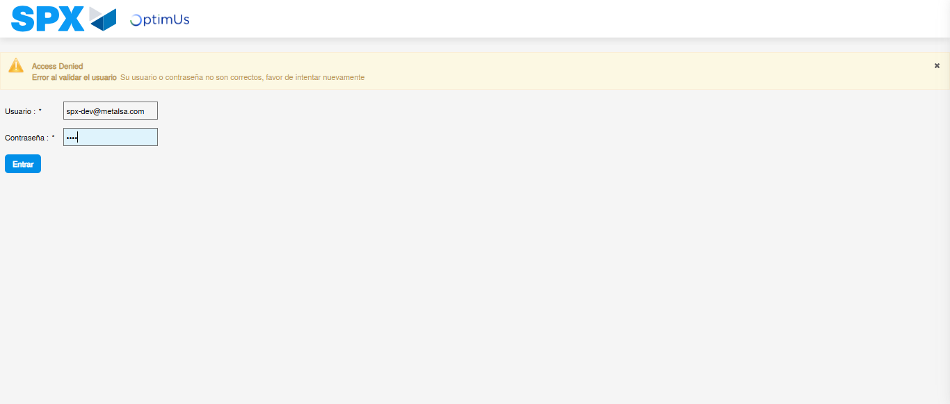Image file-name: QC_Testing-runTestMultipleTimes-dic. 03 2025, 09 27 03 a. m.

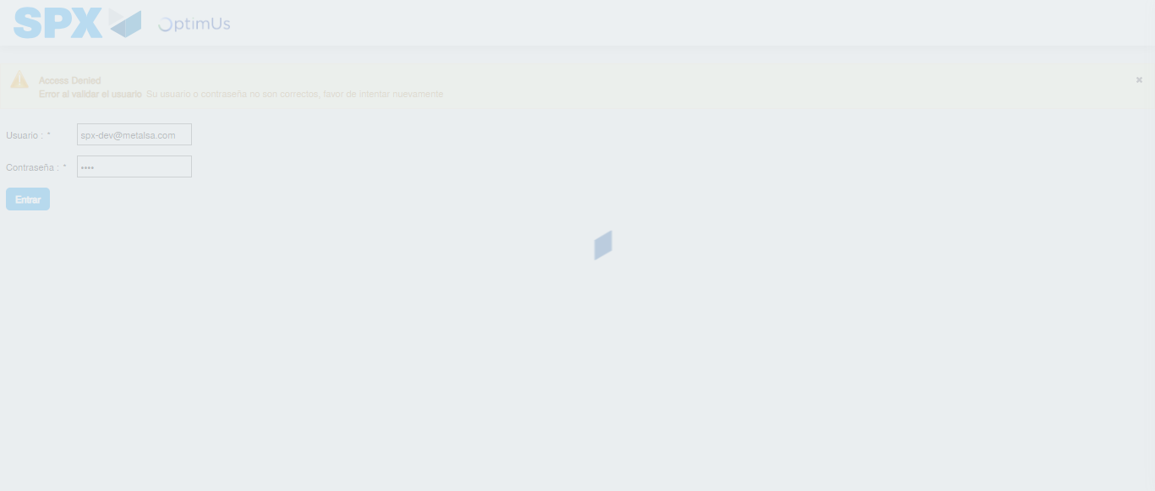Image file-name: QC_Testing-runTestMultipleTimes-dic. 03 2025, 09 27 04 a. m.

Step 2 - Select to UEN and Access to Administrador Roles Menu: UEN Correctly selected and Correct access
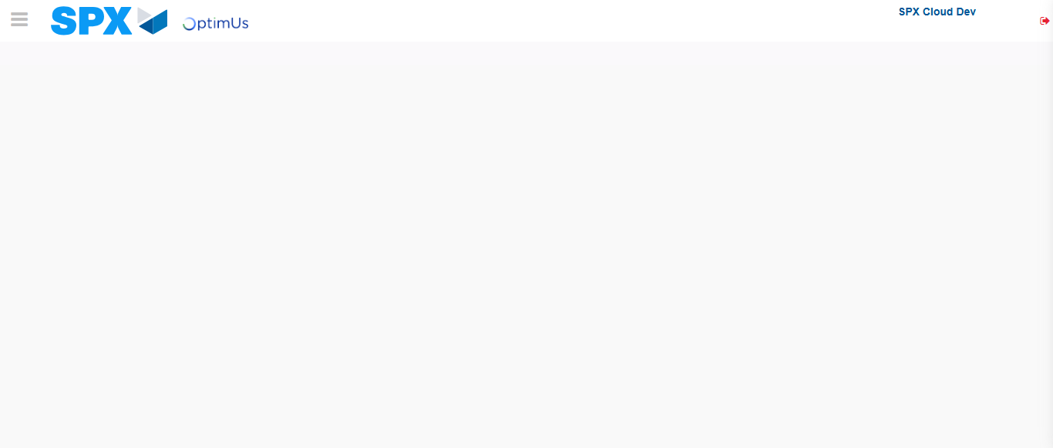Image file-name: QC_Testing-runTestMultipleTimes-dic. 03 2025, 09 27 07 a. m.

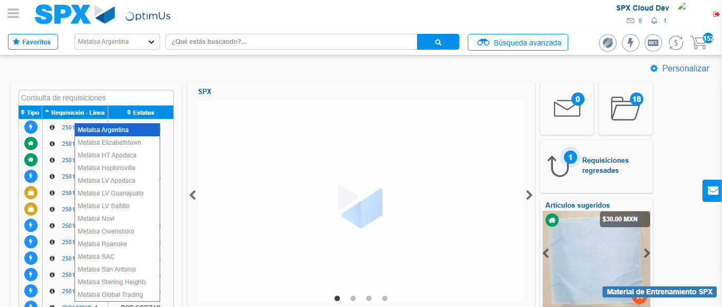Image file-name: QC_Testing-runTestMultipleTimes-dic. 03 2025, 09 27 08 a. m.

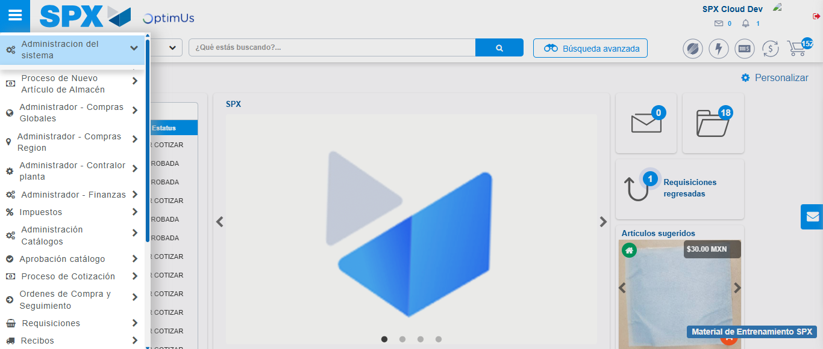Image file-name: QC_Testing-runTestMultipleTimes-dic. 03 2025, 09 27 09 a. m.

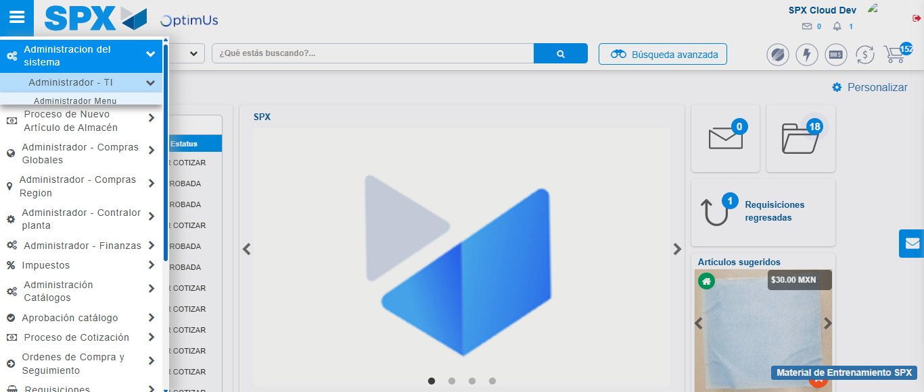Image file-name: QC_Testing-runTestMultipleTimes-dic. 03 2025, 09 27 10 a. m.

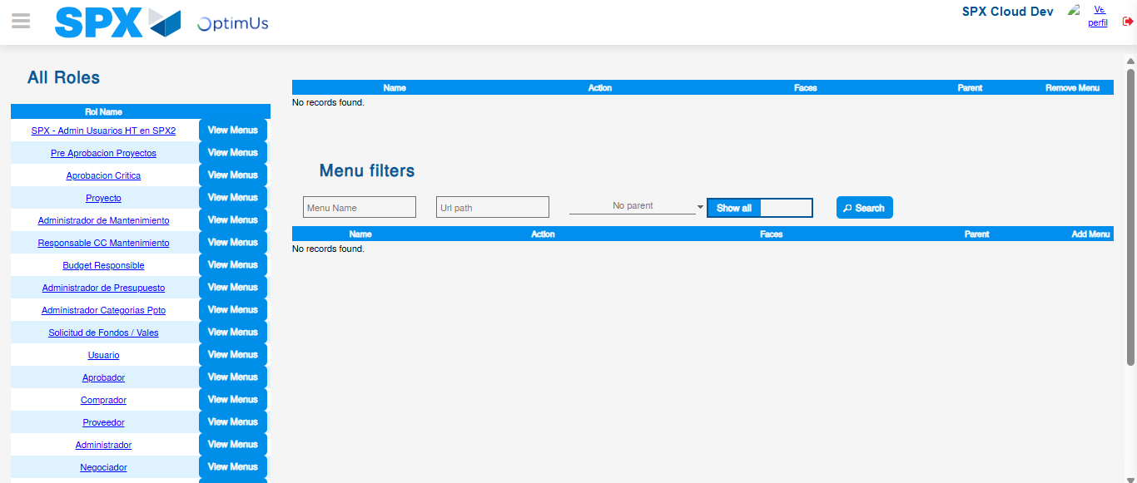Image file-name: QC_Testing-runTestMultipleTimes-dic. 03 2025, 09 27 13 a. m.

Step 3 - Click to Buttons View Menu and Search Filter with Menu Name: Correct Search
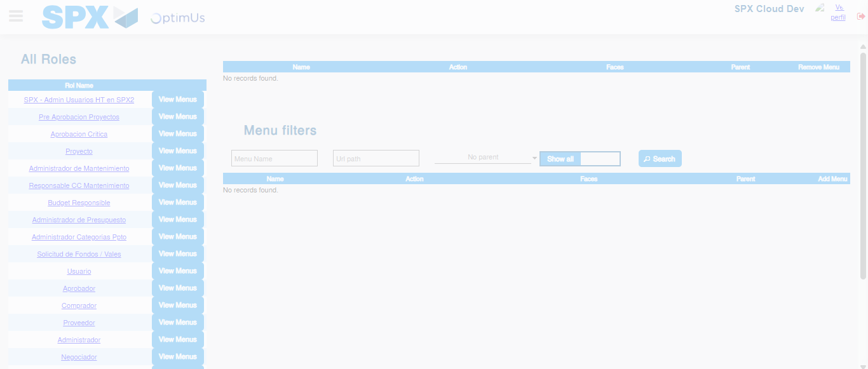Image file-name: QC_Testing-runTestMultipleTimes-dic. 03 2025, 09 27 14 a. m.

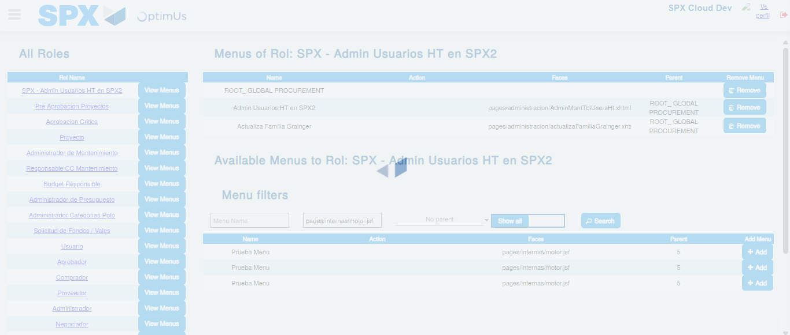Image file-name: QC_Testing-runTestMultipleTimes-dic. 03 2025, 09 27 15 a. m.

